**Programming Assignment 3-3**

**1. Problem Definition**

The primary purpose of this program is to validate an email address based on specific criteria. The criteria are :a) It must start with the alphabet character ; b) The input string length is greater than 5 and less than 30; c) It must include the letter ‘@’; d) It must include at least one ‘.’ after ‘@’

**2. Input and Output**

Input: An email address   
Output: True if the email address is valid, False otherwise

**3. Variables**

email: the email address input by the user  
at_index: the index of the '@' character in the email  
dot_index: the index of the '.' character after the '@' in the email

4. Flow Chart

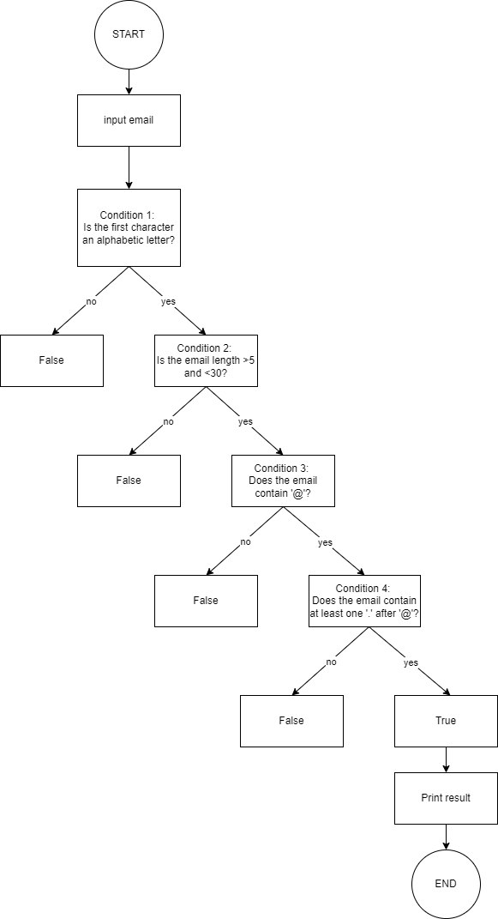

5. Errors and Lessons

-Missing Colon After if Statement:

Error:

if not email[0].isalpha()

Fix: Ensure a colon is added at the end of the if statement: if not email[0].isalpha():

if not email[0].isalpha():

- Logical Errors in Conditions:

Error: Incorrect logical conditions that do not properly validate the email.

Fix: Ensure that logical conditions are accurately checking the required criteria.